IMAGE CLASSIFICATION USING DEEP LEARNING

MGT-661-N23SF Artificial Intelligence & Business Analysis Graduate

Course Instructor - Dr. Mighty Itauma

Presented by –

Nidharsan Reddy
Master’s in business Analytics, at Northwood University
papireddypn50@northwood.edu

Mahitha Kopuru

Master’s in business Analytics, at Northwood University

kopurus86@northwood.edu

Krishna Vardhan

Master’s in business Analytics, at Northwood University

nettimikv19@northwood.edu

Vineeth Goud

Master’s in business Analytics, at Northwood University

bodav90@northwood.edu

Abstract: The purpose of this paper is to discuss image classification using a deep neural network (DNN), also known as deep learning. Image classification is now used to bridge the gap between computer vision and human vision, allowing machines to recognize images in the same way that humans can. It assigned tasks to image classes. Then we propose an image classification system based on deep learning, which uses algorithms such as neural networks to classify images. Here we are using the TensorFlow framework and Python programming language to build the system.

Keywords: Image classification, Deep learning, TensorFlow, Convolutional Neural Networks, Artificial Intelligence, python

Introduction
The application of machine learning and deep learning to plant disease detection has grown in popularity, with promising results in accurately identifying plant diseases from digital images. Traditional machine learning techniques, such as feature extraction and classification, have been applied in the detection of plant diseases. These methods use image features like color, texture, and shape to train a classifier that can identify the difference between healthy and diseased plants. These methods have been widely used for detecting diseases such as leaf blotch, powdery mildew, and rust, as well as disease symptoms caused by abiotic factors such as drought and nutrient deficiency, but they have limitations in accurately identifying subtle disease symptoms. What is AI? how machine learning is associated with AI, and how Deep learning is associated with machine learning? AI defines the overarching objective of building intelligent systems with the aim of image classification. The fundamental algorithms and methodologies for training models to recognize patterns in images using machine learning. Deep learning provides the use of the strength of artificial neural networks to achieve advanced performance in image classification tasks.
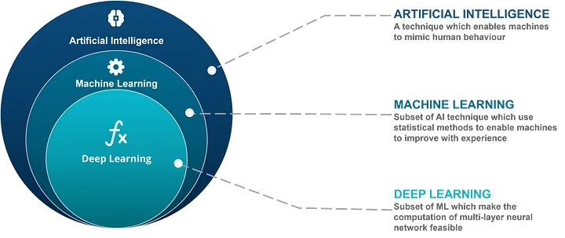
Figure 1 - Relationship between AI, ML, and DL

ARTIFICIAL NEURAL NETWORKS

Artificial neural networks (ANN) are inspired by the human brain and replicate its structure to learn from the provided data. ANNs, like neurons in the brain, contain interconnected nodes called artificial neurons that process information. Because these nodes are organized in layers, the network can extract complex patterns from the provided data. ANNs are powerful machine learning tools that can perform tasks such as image recognition, natural language processing, and even forecasting future events. These neural networks consist of interconnected nodes called artificial neurons that process information a multi-layered neural network can be proposed as an alternative to the above scenario. When we process the raw data, the machine takes the data and then trains the data allowing the machine to learn by itself through the multilayered neural network Deep learning is the current term we use to represent multilayered networks.

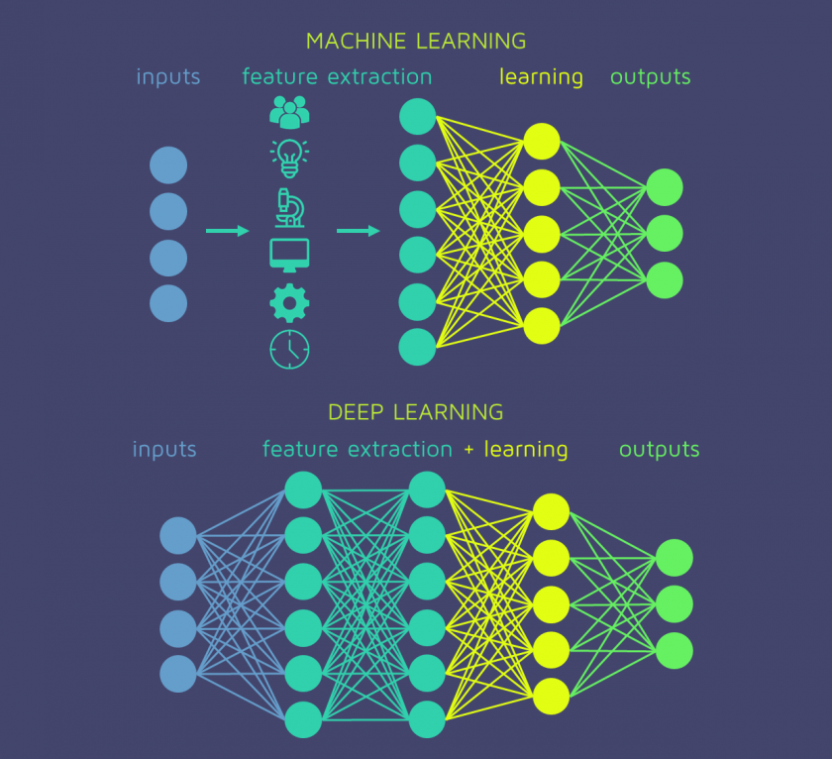
Figure 2 – how ML and DL are related.

CONVOLUTIONAL NEURAL NETWORKS(CNN)

A convolutional neural network (CNN) is a subset of machine learning. It is one of the several types of artificial neural networks that are used for different applications and data types. A CNN is a kind of network architecture for deep learning algorithms that are specifically used for image recognition and tasks that involve the processing of pixel data. These studies indicate how minor changes to a picture can drastically alter the results of grouping. Within the work, images are completely unrecognized by humans but have been classified with high accuracy rates by trained networks. There has been quick progress in the field of feature detectors and identifiers, as well as the development of various algorithms and strategies for object and scene categorization. The similarity between object detectors, texture filters, and filter banks is frequently appealing.

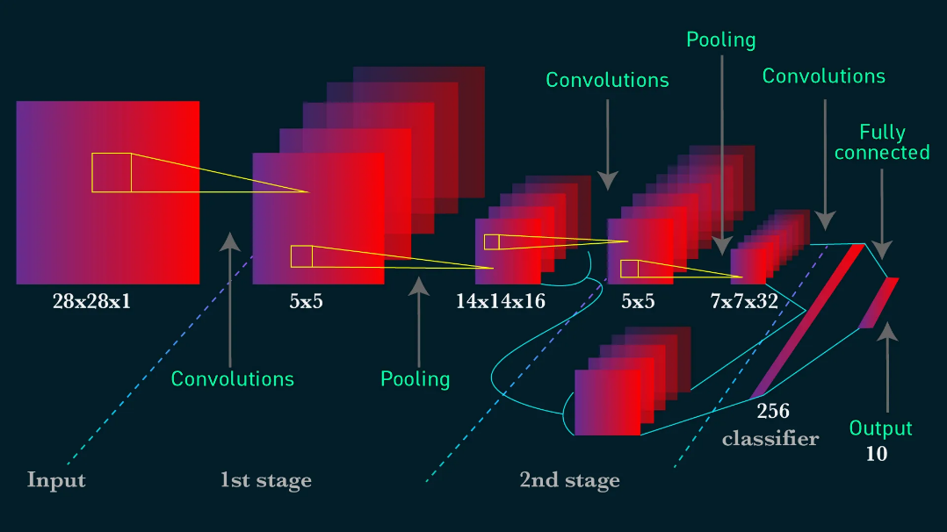
Figure 3 - convolutional neural network (CNN)

METHODOLOGY

Hence, our objective is to identify the optimal image classifier in which the primary attribute for scene categorization is the object. The convolutional neural network employs various layers, including the input layer, convolution layer, and pooling layer.
- The input layer serves as the foundational layer for each CNN, receiving images and resizing them to facilitate subsequent layers for feature extraction.
- The convolution layers function as image filters, enabling the extraction of features and calculation of matching feature points during testing.
- Consequently, the feature sets that have been extracted are forwarded to the pooling layer, which effectively reduces the size of large images while retaining essential information. This layer selects the maximum value from each window, thereby preserving the most suitable fit of each feature within the window.
TensorFlow is used to implement the image classification flowchart. This flow chart illustrates how classification begins with data exploration and comprehension. Following the creation of this input pipeline, the CNN is used to train the model. The test for CNN is dependent on the image of the leaves. If the output does not match your expectations, restart your CNN to obtain accurate results. When the output falls into the specified category, the process is complete.

IMAGE CLASSIFICATION MODEL

The decision-making process in a CNN for leaf disease detection starts with the input of an image of a leaf. The image is then passed through the convolutional layers, where features are extracted. The feature vectors are then processed by pooling layers,
where the spatial dimensions are reduced. The feature vectors are then transmitted via the FC layers, where a decision is made about the presence of a disease or pest. The model's output is the probability that the leaf is diseased or healthy. CNNs are well-suited for leaf disease detection, thanks to their architecture consisting of up-sampling, down-sampling, and learnable layers. The learning process of CNN involves training the network using labeled images of healthy and disease-affected plants. Presents a framework for classifying the plants into normal and abnormal plants using leaf data. The framework employs several different Inception architectures, and the final decision is made through a bagging-based approach. TensorFlow is a powerful data flow and differentiable programming library, allowing for efficient computation on a variety of devices with powerful hardware such as memory, GPUs, and TPUs. It is a popular choice for machine learning and deep learning applications due to its ability to generate data flow graphs, which describe how data moves through a computation. Keras, on the other hand, is a high-end deep-learning library that runs on top of TensorFlow (as well as some other libraries). It makes it easier to create DL models by providing a user-friendly API and several pre-built layers and functions, such as convolutional layers and pooling layers, which can be easily added to a model. In recent TensorFlow versions.

IMAGE CLASSIFICATION FLOW CHART
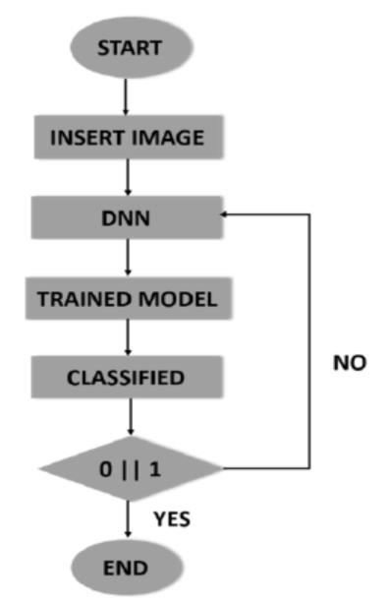

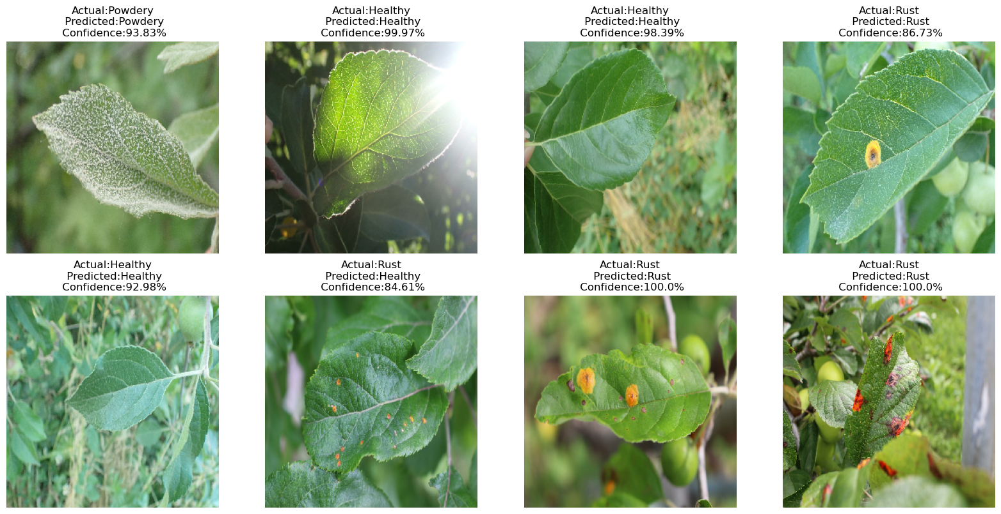
Figure 4 – Image predictions of the trained model

MODEL EVALUATION

Image classification models used in real-world applications are included in deep learning models. Many methods have been developed and are still being developed. As a result, here are some fundamentals of other models in comparison to advanced CNNs.
- Convolutional Neural Networks (CNN) have proven to be extremely effective in image classification and object recognition. Identification, recognition, and so on. When compared to DNN, the results here are highly optimized. However, the loss of verification with CNNs is high, resulting in overfitting.
- Another method for reusing acquired knowledge is transfer learning. This means that previously trained models will be used in large datasets to achieve good results in relevant work. However, the precision is high and the time is shorter than with other products.

Accuracy and Loss on Train and Test

42/42 [==============================] - 27s 586ms/step - loss: 0.3185 - accuracy: 0.9092
Loss on Train data: 0.3185355067253113
Accuracy on Train data: 0.9092284440994263
42/42 [==============================] - 26s 564ms/step - loss: 0.3185 - accuracy: 0.9092
Loss on Train data: 0.3185354769229889
Accuracy on Train data: 0.9092284440994263
5/5 [==============================] - 3s 392ms/step - loss: 0.5297 - accuracy: 0.8800
Loss on Test data: 0.5297175645828247
Accuracy on Test data: 0.8799999952316284
- Loss on Train data: 0.3185:
The overall loss on the entire training dataset is 0.3185.
- Accuracy on Train data: 0.9092:
The accuracy achieved on the training dataset is approximately 90.92%.

In summary, your model achieved a relatively low loss and a high accuracy of approximately 90.92% on the training dataset after completing the training process. This indicates that the model has learned to make accurate predictions based on the data against which it was trained.

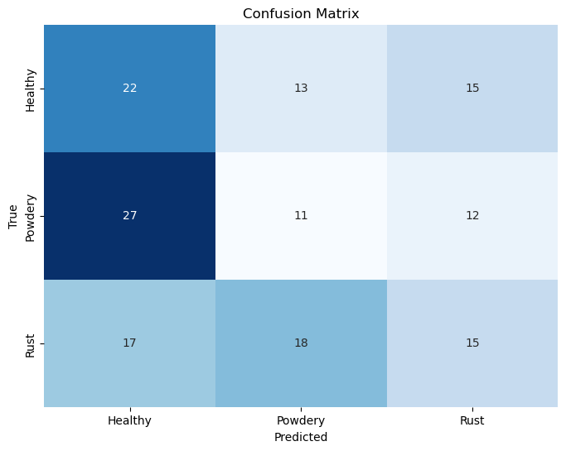
Figure 5 – confusion matrix

Classification Report:

precision recall f1-score support
0 0.33 0.44 0.38 50
1 0.26 0.22 0.24 50
2 0.36 0.30 0.33 50
accuracy 0.32 150
macro avg 0.32 0.32 0.31 15
weighted avg 0.32 0.32 0.31 150

In conclusion, our model has low precision, recall, and F1-score values for each class, with an overall accuracy of 32%. It is critical to consider your application's specific requirements and potentially investigate ways to improve model performance, such as adjusting the hyperparameters collecting more data, or using more complex models.

CONCLUSION

Finally, this research focuses on plant disease classification with TensorFlow and deep learning. During this study, three objectives were met. The objectives and conclusions are inextricably linked because they determine whether or not all of the objectives are met. It is possible to say that all of the findings obtained thus far have been extremely impressive. The deep neural network (DNN) is the primary focus of this research, especially in the field of plant disease. The DNN technique was studied in greater depth, beginning with image assembly, training models, and classification into categories. DNN's epochs were able to control accuracy while also preventing issues like overfitting. The use of TensorFlow to implement deep learning produced positive results. Finally, this research focuses on plant disease classification with TensorFlow and deep learning. During this study, three objectives were met. The objectives and conclusions are inextricably linked because they determine whether or not all of the objectives are met. It is possible to say that all of the findings obtained thus far have been extremely impressive. The deep neural network (DNN) is the primary focus of this research, especially in the field of plant disease. The DNN technique was studied in greater depth, beginning with image assembly, training models, and classification into categories. DNN's epochs were able to control accuracy while also preventing issues like overfitting. The use of TensorFlow to implement deep learning produced positive results.

REFERENCES

[1] A case study of image classification based on deep learning using TensorFlow
JD Kothari - … Image Classification Based on Deep Learning Using …, 2018 - papers.ssrn.com

[2]https://typeset.io/pdf/an-advanced-deep-learning-models-based-plant-disease- 1wav3hy3.pdf
[3] Understanding image classification using TensorFlow deep learning-convolution neural network
VK Gunjan, R Pathak, O Singh - … and the Internet of Things (IJHIoT), 2019 - igi-global.com

[4] Tensorflow based image classification using advanced convolutional neural network
P Kumar, U Dugal - International Journal of Recent …, 2020 - pdfs.semanticscholar.org

[5] Learn TensorFlow 2.0: Implement Machine Learning and Deep Learning Models with Python
P Singh, A Manure - 2019 - books.google.com

[6] Learning Deep Learning: Theory and Practice of Neural Networks, Computer Vision, Natural Language Processing, and Transformers Using TensorFlow
M Ekman - 2021 - books.google.com

